**Ganpat University**

**Faculty of Engineering & Technology**

**Computer Science & Engineering**

**(2CSE204) Basics of Operating System and Shell Scripting**

***Institute of Computer And Technology***

***B.Tech – CSE(BDA)***

***Name:- Dwij Vatsal Desai***

***Sem:- 2***

***Sub: - BOSS***

***Enrollment No.:- 23162121027***

***Prac:- 1***

***Date:- 15/2/2024***

**Practical 1**

1.From student user, change the user to root and identify which user is currently logged in?

**Commands:-**

[ddesai@localhost ~]$ whoami

ddesai

[ddesai@localhost ~]$ su - root

Password:

[root@localhost ~]#

**Screenshorts:-**

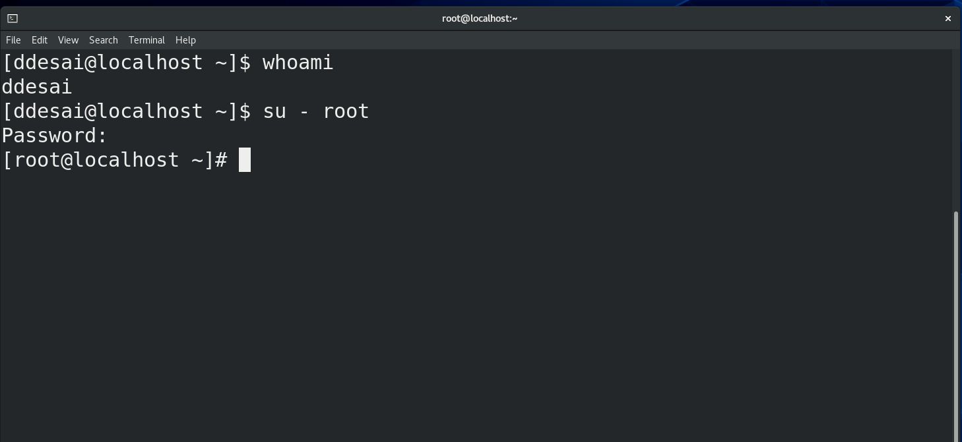

1. Display current date and time in following format:

***dd/mm/yyyy-hh:mm:ss***

**Commands:-**

[ddesai@localhost ~]$ date

Thu Feb 15 05:57:27 EST 2024

[ddesai@localhost ~]$

**Screenshorts:-**

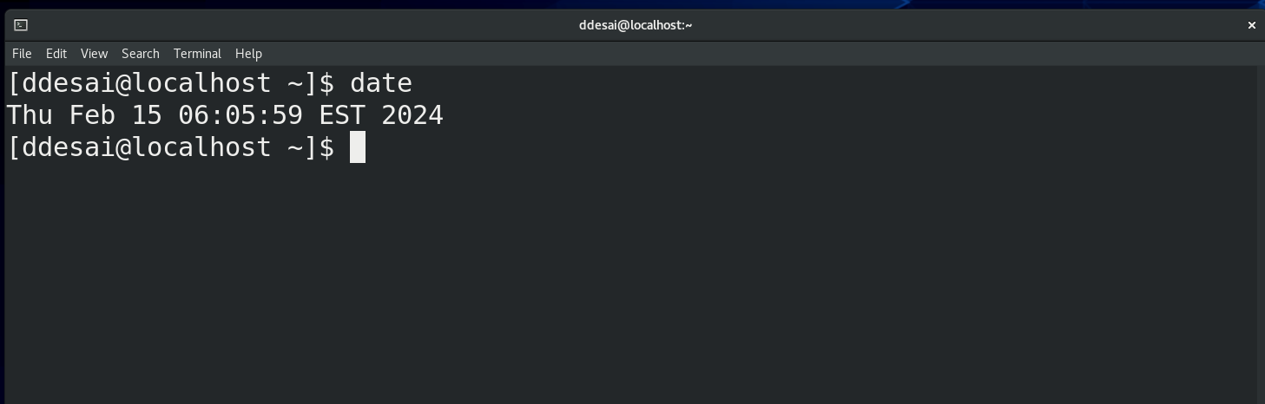

1. Using multiple commands in one line only, display current month name in full and day in abbreviated format.

**Commands:-**

[ddesai@localhost ~]$ echo -e "\e[34m$(date "+%B") \e[0m\e[32m$(date "+%a")\e[0m"

February Thu

[ddesai@localhost ~]$

**Screenshorts:-**

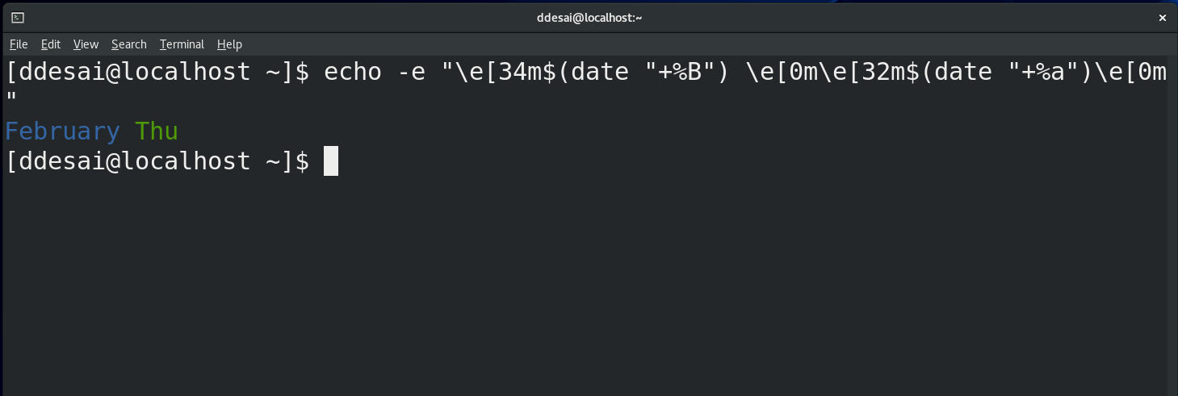

1. Display first 4 lines of /etc/yum.repos.d/rhel_dvd.repo file

**Commands:-**

head -n 4 /etc/yum.repos.d/rhel_dvd.repo

**Screenshorts:-**

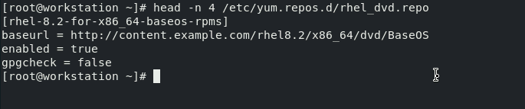

1. Display last 5 lines of /etc/yum.repos.d/rhel_dvd.repo file

**Commands:-**

tail -n 5 /etc/yum.repos.d/rhel_dvd.repo

**Screenshorts:-**

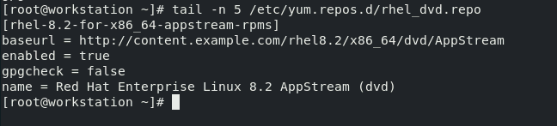

1. How many bytes are occupied by /var/log/secure file?

**Commands:-**

[root@localhost ~]# wc --c /var/log/secure

9623 /var/log/secure

[root@localhost ~]#

**Screenshorts:-**

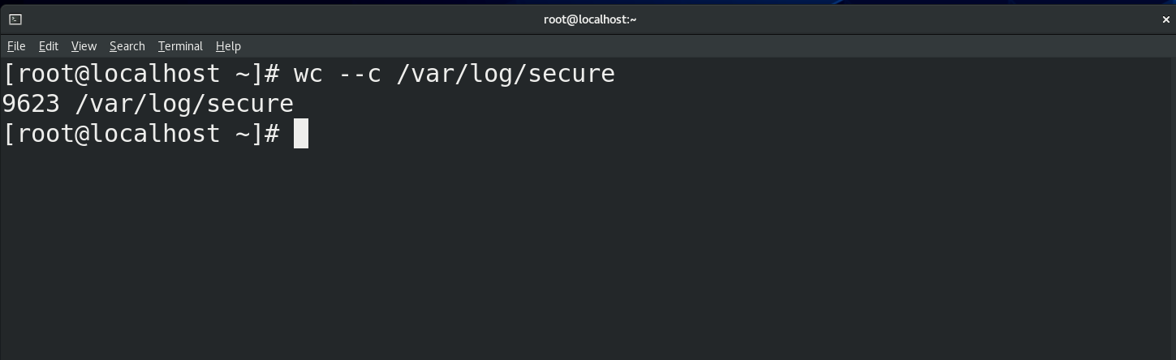

1. How many lines of content is present in /etc/shadow file?

**Commands:-**

[root@localhost ~]# wc -l /etc/shadow

45 /etc/shadow

[root@localhost ~]#

**Screenshorts:-**

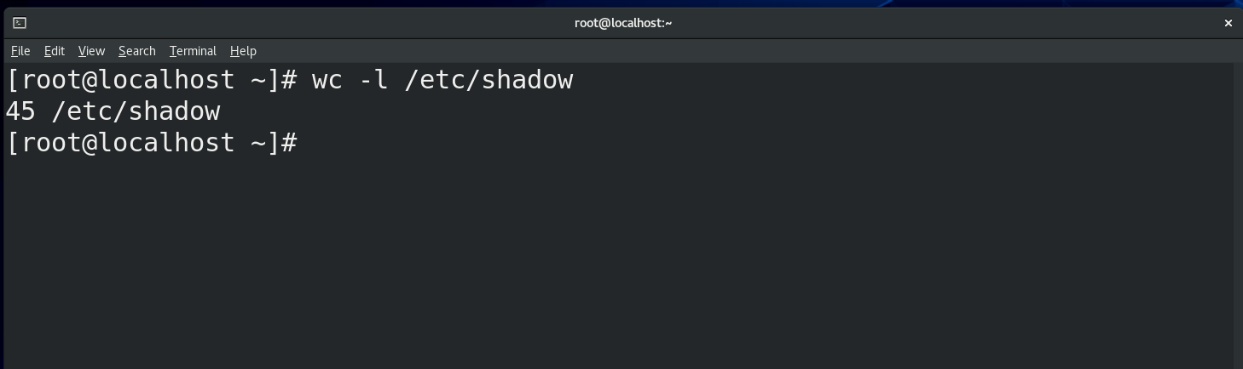

1. List all the commands executed by you so far and execute the 10th command.

**Commands:-**

1 whoami

2 date

3 su – student

4 su - ddesai

5 head -n 4 /etc/yum.repos.d/rehel_dvd.repo

6 ls -l /var/log/secure

7 wc --c /var/log/secure

8 wc --c /var/log/secure

9 wc -l /var/shadow

10 wc -l /etc/shadow

**Screenshorts:-**

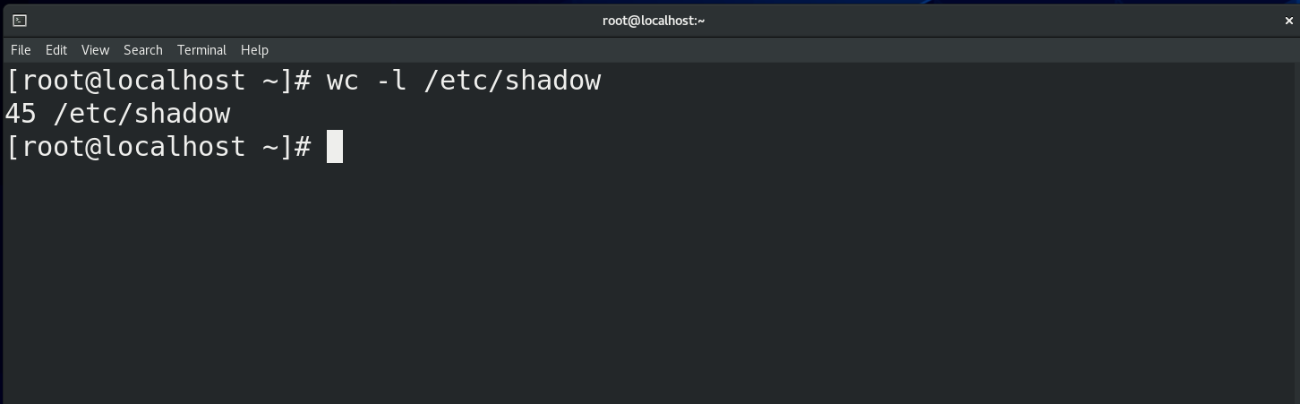

1. Display the contents of /var/log/secure file.

**Commands:-**

[root@localhost ~]# cat /var/log/secure

**Screenshorts:-**

